A
Mini Project Report
on

“Library Management System”

Presented by
“Mohd Asjad Inamdar”

SY[CSE-B]
Computer Science and Engineering
( 2025 – 2026 )

Guided By

<Ms. Deepashri S Naik>
(Department of Computer Science and Engineering)

Submitted to



MGM’s College of Engineering, Nanded

Under

Dr. Babasaheb Ambedkar Technological University, Lonere

Certificate
This is to certify that the mini project entitled

“Library Management System”
Submitted By
“Mohd Asjad Inamdar”
In satisfactory manner as a partial fulfillment of
TY[CSE] in Computer Science and Engineering

To

MGM’s College of Engineering, Nanded

Under
Dr. Babasaheb Ambedkar Technological University, Lonere
has been carried out under my guidance,

Ms. Deepashri S Naik
Mini Project Guide

Dr. Mrs. A. M. Rajurkar Dr. Mrs. G. S. Lathkar
H.O.D Director
Computer Science & Engineering MGM’s College of Engg., Nanded

Table of Contents

Acknowledgement | I
Abstract | II
Table of Contents | III
List of Figures | V
List of Tables | VI
Chapter 1. Introduction | 1
1.1 Problem Statement | 1
1.2 Objective of the Project | 1
1.3 Scope of the Project | 1
1.4 Existing System | 1
1.5 Proposed System | 1
Chapter 2. System Requirements | 3
2.1 Hardware Requirements | 3
2.2 Software Requirements | 3
Chapter 3. System Analysis | 4
3.1 Feasibility Study | 4
3.2 System Flow | 4
Chapter 4. System Design | 5
4.1 Use Case Diagram | 5
4.2 Class Diagram | 6
4.3 Flowchart | 7
Chapter 5. Methodology / Technology Used | 8
5.1 Java OOP Concepts | 8
5.2 Data Structures | 8
5.2.1 Singly Linked List (For Book Management)  5.2.2 Queue (For Waiting List) | 8
5.3 Exception Handling | 8
Chapter 6. Implementation | 9
6.1 Code Snippets | 9
6.2 Description of Modules | 17
Chapter 7. Testing  7.1 Test Cases | 18
Chapter 8. Results | 19
8.1 Final Output | 19
8.2 Terminal Screenshots | 20
Conclusion | 21
References | 22

List of Figures

Figure No. | Name of Figure | Page No.
1.1 | Challenges in Library Management | 2
4.1 | Use Case Diagram | 5
4.2 | Class Diagram | 6
4.3 | Flowchart | 7
8.1 | Terminal Screenshots 1 | 20
8.2 | Terminal Screenshots 2 | 20

List of Tables
Table No. | Name of Table | Page No.
7.1 | Output Table | 18

ACKNOWLEDGMENT

I am greatly indebted to our mini project guide, Ms. Deepashri S Naik , for his/her able guidance, and we would like to thank him/her for his/her help, suggestions, and numerous helpful discussions.
We gladly take this opportunity to thank Dr. A. Rajurkar (Head of Computer Science and Engineering, MGM's College of Engineering, Nanded).
I am heartily thankful to Dr. G. S. Lathkar (Director, MGM's College of Engineering, Nanded) for providing facilities during the progress of the mini project and for her kind guidance and inspiration.
Last but not least, I am also thankful to all those who helped directly or indirectly in the complete and successful development of this mini project.

With Deep Reverence,
Mohd Asjad Inamdar SY [CSE-B]
ABSTRACT

The Library Management System is a console-based application designed to streamline the management of book records within a library. Traditional manual methods of library management are often time-consuming and prone to human error. This project addresses these issues by automating key processes such as adding books, displaying inventory, issuing books to students, and handling returns.
The core technical strength of this project lies in its efficient use of Data Structures. Unlike simple array-based systems, this project utilizes a Singly Linked List to manage the catalog of books dynamically, ensuring no memory is wasted. Furthermore, it implements a Queue data structure to handle book reservations; if a book is out of stock, students are automatically added to a waiting list (queue) and served in a First-Come-First-Serve (FCFS) manner upon return.
This system demonstrates the practical application of Object-Oriented Programming (OOP) concepts in Java, providing a scalable and efficient solution for basic library operations.

Chapter 1. Introduction

1.1 Problem Statement
In many small to medium-sized libraries, maintaining book records manually in registers is a tedious task. Librarians struggle to track how many copies of a book are available or who is currently holding a book. Furthermore, when a popular book is out of stock, there is often no organized system to manage the waiting list of students, leading to confusion and unfair allocation when the book is returned.

1.2 Objective of the Project
The main objective of this project is to develop a software solution that:
- Automates the storage and retrieval of book details.
- Efficiently manages memory using Dynamic Memory Allocation.
- Implements a fair waiting list system using Queues for out-of-stock books.
- Provides a user-friendly console interface for the librarian.

1.3 Scope of the Project
The project is a console-based application targeted at educational institutes or small libraries. It covers the fundamental operations of a library (Add, Show, Issue, Return). Future scopes could include integrating a database (MySQL) or a Graphical User Interface (GUI).

1.4 Existing System
The existing system relies on static arrays or manual paperwork.
- Limitation: Arrays have a fixed size. If the library buys more books than the array size, the code fails. If fewer books are present, memory is wasted.
- Limitation: No automatic queue management for waiting students.

1.5 Proposed System
The proposed system uses Linked Lists to store books.
- Advantage: The number of books can grow or shrink dynamically at runtime.
- Advantage: A Queue is used to store the names of students waiting for a specific book, ensuring the book is issued to the next person in line automatically upon return.

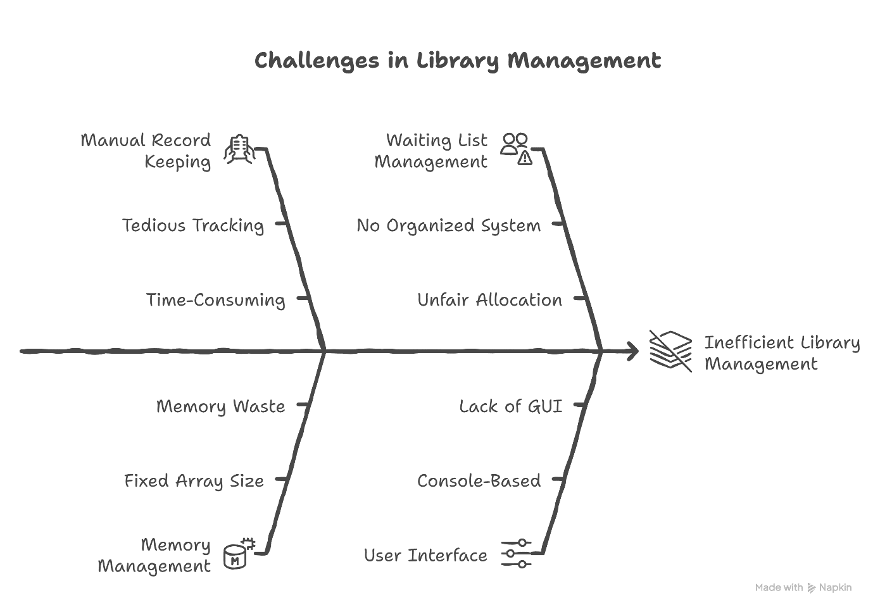
Fig. 1.1
Chapter 2. System Requirements

2.1 Hardware Requirements
To run this application efficiently, the following hardware is recommended:
- Processor: Intel Core i3 or higher / AMD equivalent.
- RAM: 4 GB or higher.
- Hard Disk: Minimum 100 MB free space for JDK and project files.
- Input Device: Keyboard.

2.2 Software Requirements
- Operating System: Windows 10/11, Ubuntu (Linux), or macOS.
- Programming Language: Java (JDK 8 or higher).
- IDE/Editor: VS Code, Eclipse, or IntelliJ IDEA.
- Compiler: Javac.

Chapter 3. System Analysis

3.1 Feasibility Study
- Technical Feasibility: The project is highly feasible as it uses standard Java libraries (java.util.Scanner) and fundamental data structures. No external expensive hardware or proprietary software is required.
- Operational Feasibility: The system is easy to use. The menu-driven interface ("Enter choice: 1") requires no special training for the operator.
- Economic Feasibility: The project is developed using open-source technologies (Java), making it zero-cost to deploy.

3.2 System Flow
The system follows a linear flow controlled by a do-while loop:
- Start
- Display Menu
- Read User Choice
- Execute corresponding method (addBook, issueBook, etc.)
- Repeat until "Exit" is selected.

Chapter 4. System Design

4.1 Use Case Diagram
The primary actor in this system is the Librarian.
- Actor: Librarian
- Use Cases: Add Book, View Inventory, Issue Book, Return Book, Manage Waiting Queue.
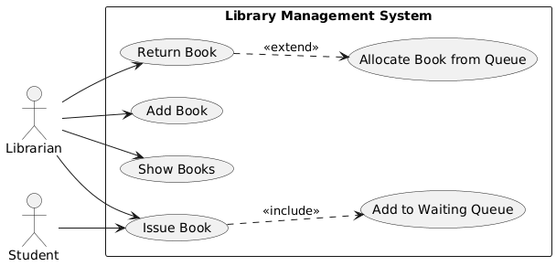

Fig.4.1

4.2 Class Diagram
The system is composed of three main classes:
- Class Book: Represents a node in the Linked List. Attributes: id, name, author, quantity, next.
- Class StudentNode: Represents a node in the Queue. Attributes: name, next.
- Class LibraryManagementSystem: Contains the main method and static methods for operations (addBook(), issueBook(), etc.).
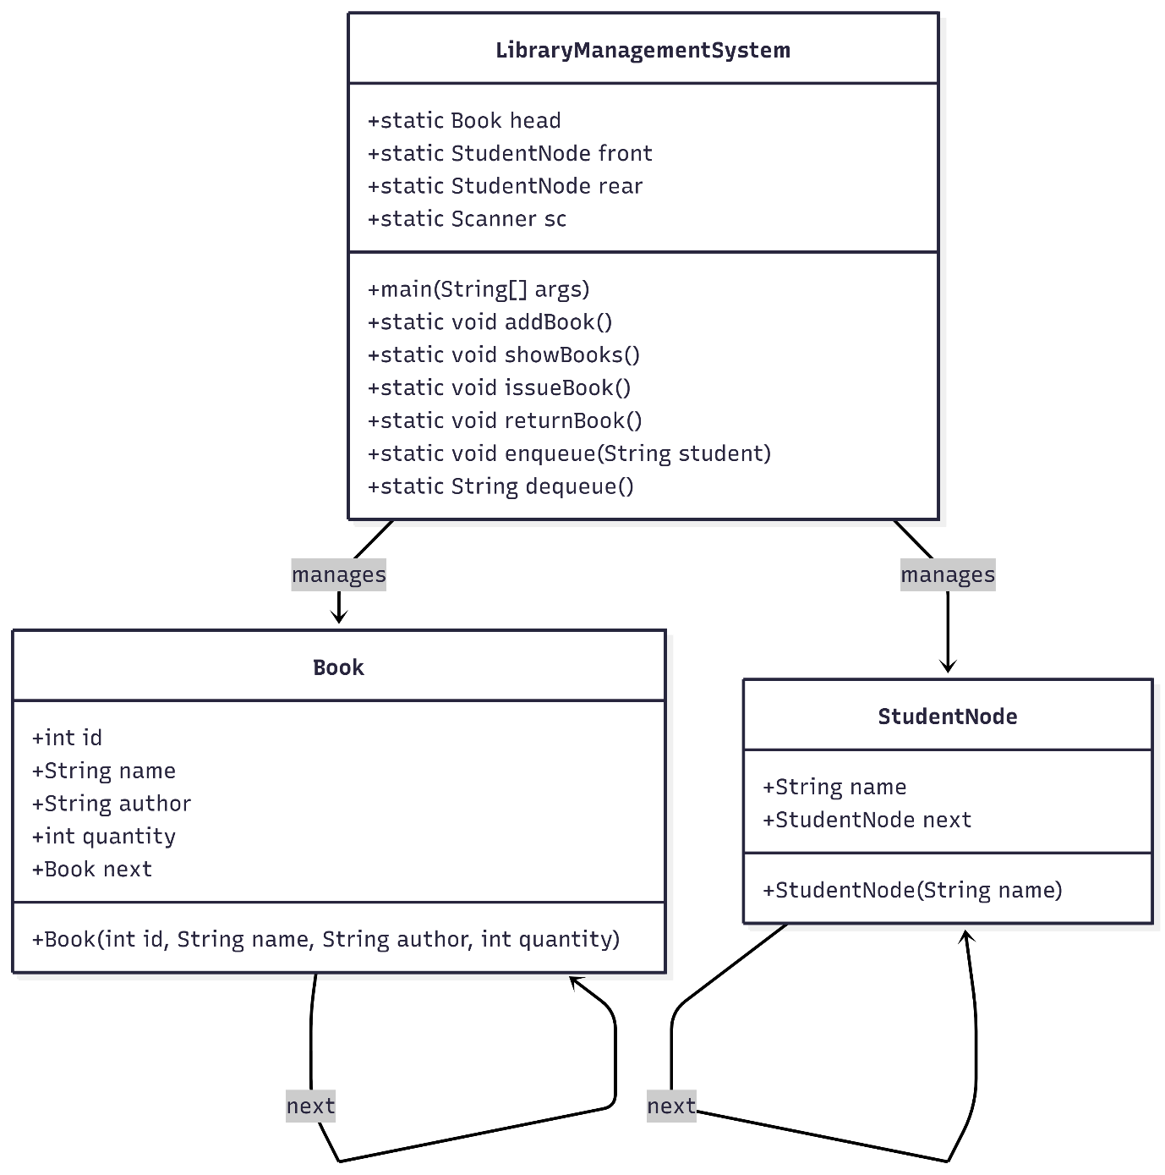

Fig. 4.2
4.3 Flowchart
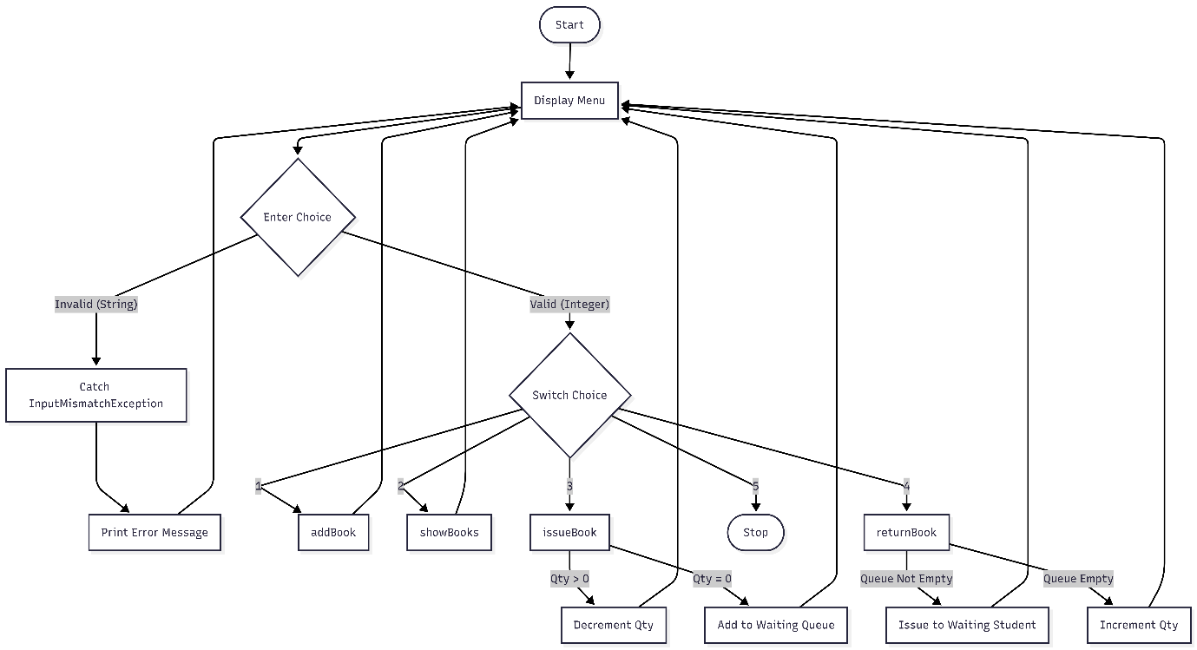
Fig 4.3
Chapter 5. Methodology / Technology Used

5.1 Java OOP Concepts
- Encapsulation: Data and methods are bundled within classes (Book, LibraryManagementSystem).
- Object Initialization: Constructors are used to initialize Book and StudentNode objects.

5.2 Data Structures
This is the core methodology of the project.

5.2.1 Singly Linked List (For Book Management)
Instead of an array Book[], we use a Linked List.
- Head Pointer: static Book head = null;
- Logic: When adding a book, we traverse to the end of the list and attach a new node. This allows infinite expansion of the library catalog without code changes.

5.2.2 Queue (For Waiting List)
A FIFO (First-In-First-Out) Queue is implemented using a Linked List approach.
- Pointers: front and rear.
- Logic: When a book is issued but quantity == 0, the student is enqueued. When a book is returned, if the queue is not empty, the student at the front is dequeued and assigned the book immediately.

5.3 Exception Handling
- Robustness: The program uses try-catch blocks to handle runtime errors.
- InputMismatchException: Specifically imported from java.util to catch instances where a user inputs a non-integer (e.g., "abc") when an integer (e.g., Book ID) is expected. This prevents the "crash" scenario and allows the user to retry.
Chapter 6. Implementation

6.1 Code Snippets

import java.util.Scanner;

import java.util.InputMismatchException;

class Book {

int id;

String name;

String author;

int quantity;

Book next;

Book(int id, String name, String author, int quantity) {

this.id = id;

this.name = name;

this.author = author;

this.quantity = quantity;

this.next = null;

}

}

class StudentNode {

String name;

StudentNode next;

StudentNode(String name) {

this.name = name;

this.next = null;

}

}

class LibraryManagementSystem {

static Book head = null;

static StudentNode front = null;

static StudentNode rear = null;

static Scanner sc = new Scanner(System.in);

public static void main(String[] args) {

int choice;

do {

System.out.println("\n----- LIBRARY MENU -----");

System.out.println("1. Add Book");

System.out.println("2. Show Books");

System.out.println("3. Issue Book");

System.out.println("4. Return Book");

System.out.println("5. Exit");

System.out.print("Enter choice: ");

try {

choice = sc.nextInt();

} catch (InputMismatchException e) {

System.out.println("Invalid input! Please enter a number.");

sc.nextLine(); // Clear buffer

choice = 0; // Loop again

}

switch (choice) {

case 1: addBook(); break;

case 2: showBooks(); break;

case 3: issueBook(); break;

case 4: returnBook(); break;

case 5: System.out.println("Exiting program..."); break;

default: System.out.println("Wrong choice!");

}

} while (choice != 5);

}

static void addBook() {

try {

System.out.print("Enter Book ID: ");

int id = sc.nextInt();

sc.nextLine();

System.out.print("Enter Book Name: ");

String name = sc.nextLine();

System.out.print("Enter Author Name: ");

String author = sc.nextLine();

System.out.print("Enter Quantity: ");

int quantity = sc.nextInt();

Book newBook = new Book(id, name, author, quantity);

if (head == null) {

head = newBook;

} else {

Book temp = head;

while (temp.next != null) {

temp = temp.next;

}

temp.next = newBook;

}

System.out.println("Book added successfully.");

} catch (InputMismatchException e) {

System.out.println("Invalid input! ID and Quantity must be integers.");

sc.nextLine();

}

}

static void showBooks() {

if (head == null) {

System.out.println("No books in library.");

return;

}

Book temp = head;

int i = 1;

while (temp != null) {

System.out.println("\nBook " + i);

System.out.println("Book ID : " + temp.id);

System.out.println("Book Name : " + temp.name);

System.out.println("Author : " + temp.author);

System.out.println("Quantity : " + temp.quantity);

temp = temp.next;

i++;

}

}

static void issueBook() {

int id = -1;

try {

System.out.print("Enter Book ID to issue: ");

id = sc.nextInt();

sc.nextLine();

} catch (InputMismatchException e) {

System.out.println("Invalid input! Book ID must be an integer.");

sc.nextLine();

return;

}

Book temp = head;

while (temp != null) {

if (temp.id == id) {

System.out.print("Enter Student Name: ");

String student = sc.nextLine();

if (temp.quantity > 0) {

temp.quantity--;

System.out.println("Book issued to " + student);

} else {

enqueue(student);

System.out.println("Book not available.");

System.out.println(student + " added to waiting queue.");

}

return;

}

temp = temp.next;

}

System.out.println("Book ID not found.");

}

static void returnBook() {

int id = -1;

try {

System.out.print("Enter Book ID to return: ");

id = sc.nextInt();

} catch (InputMismatchException e) {

System.out.println("Invalid input! Book ID must be an integer.");

sc.nextLine();

return;

}

Book temp = head;

while (temp != null) {

if (temp.id == id) {

if (!isQueueEmpty()) {

String nextStudent = dequeue();

System.out.println("Book issued to waiting student: " + nextStudent);

} else {

temp.quantity++;

System.out.println("Book returned successfully.");

}

return;

}

temp = temp.next;

}

System.out.println("Book ID not found.");

}

static void enqueue(String student) {

StudentNode newNode = new StudentNode(student);

if (rear == null) {

front = rear = newNode;

} else {

rear.next = newNode;

rear = newNode;

}

}

static String dequeue() {

if (front == null) { return null; }

String name = front.name;

front = front.next;

if (front == null) { rear = null; }

return name;

}

static boolean isQueueEmpty() {

return front == null;

}

}6.2 Description of Modules
- addBook(): Appends a new book to the Linked List. Contains a try-catch block to ensure ID and Quantity are integers.
- showBooks(): Traverses the list and prints details.
- issueBook(): Checks stock. If stock is 0, adds student to Queue. Handles invalid ID input safely.
- returnBook(): Returns book or assigns to waiting student. Handles invalid ID input safely.
Chapter 7. Testing
7.1 Test Cases
Test Case ID | Feature | Input Data | Expected Output | Actual Status
TC-01 | Add Book | ID: 101, Name: Java, Qty: 5 | "Book added successfully" | Pass
TC-02 | Issue Book | ID: 101, Student: Amit | Stock becomes 4, "Book issued" | Pass
TC-03 | Issue (Out of Stock) | ID: 101, Student: Ravi (Qty=0) | "Book not available", "Ravi added to queue" | Pass
TC-04 | Return Book | ID: 101 (Queue not empty) | "Book issued to waiting student: Ravi" | Pass
TC-05 | View Books | Choice 2 | List of all books with updated quantities | Pass
Table 7.1

Chapter 8. Results

8.1 Final Output
The system successfully compiles and runs. Below is an example of the console interaction:
Menu Display:
----- LIBRARY MENU -----
1. Add Book
2. Show Books
3. Issue Book
4. Return Book
5. Exit
Enter choice: 1
Adding a Book:
Enter Book ID: 101
Enter Book Name: Data Structures
Enter Author Name: Balagurusamy
Enter Quantity: 2
Book added successfully.
Queue Demonstration: If "Data Structures" (Qty: 2) is issued to 3 students, the 3rd student is automatically placed in the waiting queue. Upon the return of one copy, the system alerts that the book has been passed to the waiting student.

Robustness Test (Add Book):
Enter Book ID: ten
Invalid input! ID and Quantity must be integers.
8.2 Terminal Screenshots
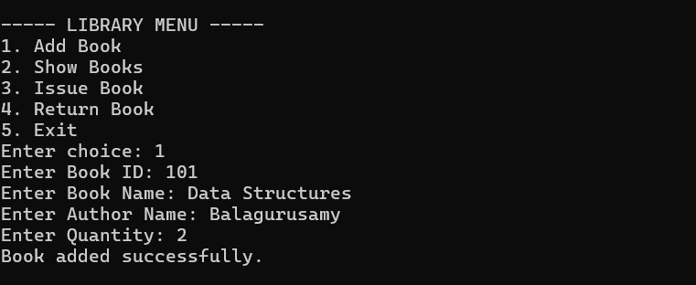
Fig. 8.1
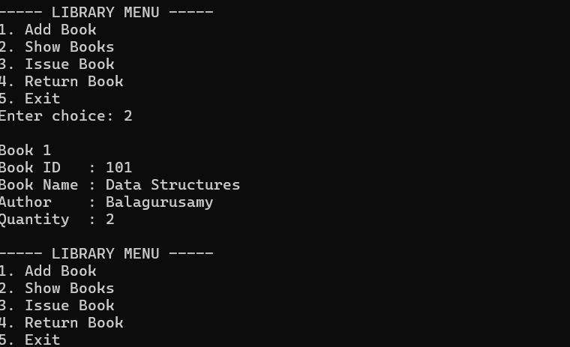
Fig. 8.2

Conclusion
The Library Management System mini project successfully demonstrates the power of Data Structures and Exception Handling in Java. By implementing Linked Lists, the system achieved dynamic memory management. By implementing try-catch blocks, the system achieved high stability, ensuring that invalid user inputs do not cause the program to crash.
Future Enhancements:
- Persistence: Save records to a file/database.
- Search: Add Search by Name feature.

REFERENCES

Books
- E. Balagurusamy, Programming with Java: A Primer, 5th Edition.
- Sierra, Kathy & Bates, Bert. Head First Java. O'Reilly Media.

Websites
- Oracle Java Documentation.
https://docs.oracle.com/javase/
- W3Schools – Java Tutorial.
https://www.w3schools.com/java/
- GeeksforGeeks – Java Programming.
https://www.geeksforgeeks.org/java/

Tools Used
- Java Development Kit (JDK 8 / above)
- Visual Studio Code / IntelliJ IDEA
- Windows Operating System

